Classroom Assignments & Technology to Assist in Student Retention
Jennifer Lauren Simpson, MPA
Texas A&M University – Corpus Christi
jennifer.simpson@tamucc.edu

Incorporating Technology in the Classroom

The students we are now teaching are of the digital age. This younger generation is more adapt and willing to email, text, develop websites, and create videos. These digital natives have even begun to learn differently than past students. This means that instructors need to adopt some new forms of technology to communicate more effectively and to build a more meaningful connection. I advise to start with a clear goal, find a teacher that is utilizing new technology for that same goal, and learn from them. If you cannot find someone at your school, then look for help on the Internet. You can also always ask your students for some advice. The key is not to to tackle it all at once. Take it one step at a time.

Remind 101

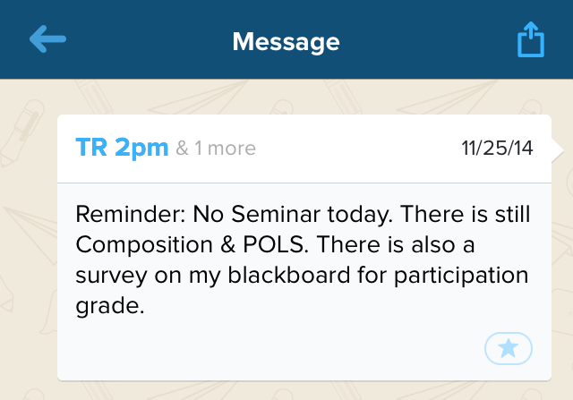
This is a free tool that allows teachers to quickly and safely keep in contact with their students via text messages. The teacher can instantly broadcast a message to an entire class or a selected few. The teacher and students never have to reveal their own personal phone numbers. The teacher can alert students of classroom changes, cancelled classes, changes in due dates or assignments, and to remind about an upcoming due date.

Text Messaging
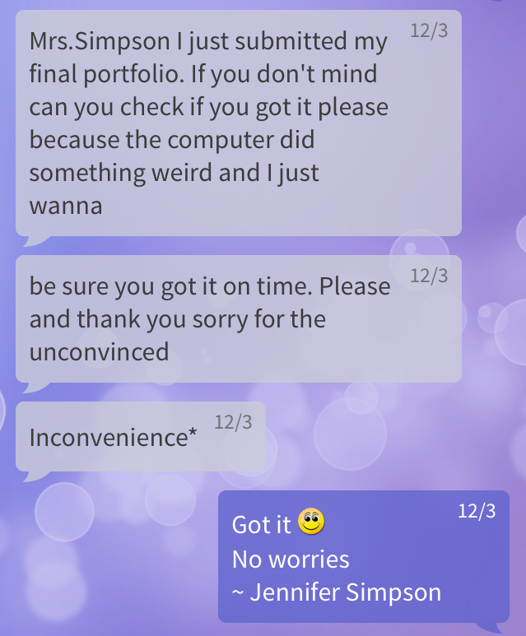
Texting students allows for increased personalized student support. It strengthens teacher-student relationships. By texting, students are more likely to stay in contact with the instructor, it allows for instant feedback for both parties and can create important bonds. There are free apps that can be used without giving out one’s personal mobile number. Some examples are Google Voice Account and Pinger. Ground rules will need to be enforced in order to foster one-on-one exchanges.

Turnitin.com
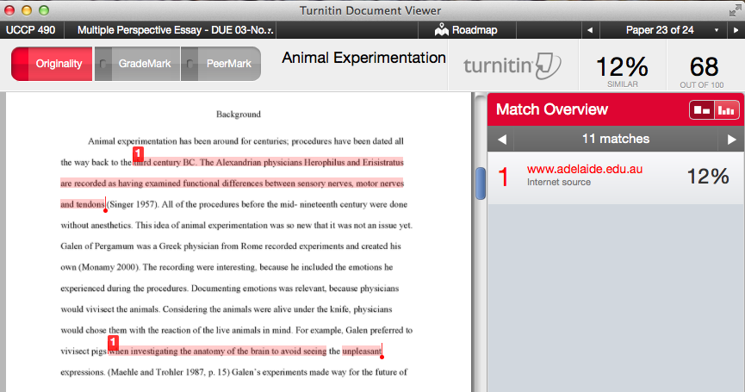
I have been using this free site for the past 3 years. It helps instructors view the originality of a student’s paper and citations (or lack there of) and allows for easy grading on a desktop computer or tablet. It also benefits the students because they can preview their paper’s originality, citation errors, and view the grading rubric. When students are able to view those things, they are more likely to improve upon their paper before a final submission. I have seen a great improvement in research paper grades since incorporating this in my classroom.

Alternatives to PowerPoint
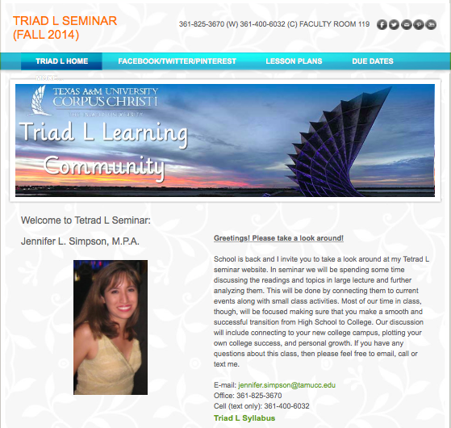
Alternative project formats allow for more interesting, engaging work and provides plenty of opportunities for students to be more creative. Including alternative formats for school projects enables students to develop new techno-logical skills that can benefit them in their presentations as well as skills that can carryover to graduate school and their future careers. Some examples of alternatives to use include: Prezi, Powtoon, Weebly, Wix, PBWorks, iMovie / Movie Maker.

Class Announcements / Reminders

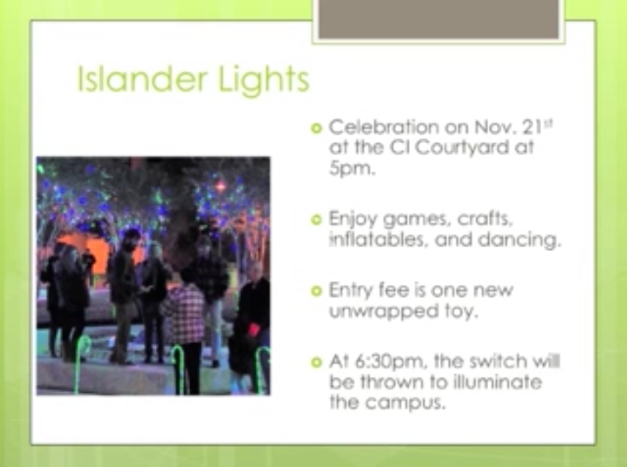
Instead of spending the first 5-10 minutes of class making announcements, I play them as a YouTube video that plays the 5-10 minutes before class and it plays as a loop. This is a great time saver. Students find them entertaining and creative and actually pay attention to what is shown. I create them using PowerPoint and then save it as pictures. Then I add them to iMovie (Movie Maker is also good). I add music as a final touch. Then I upload to YouTube. These are created for each week and take no longer than 15-30 minutes.

Anonymous Student Survey Results On The Use of These Technology Examples

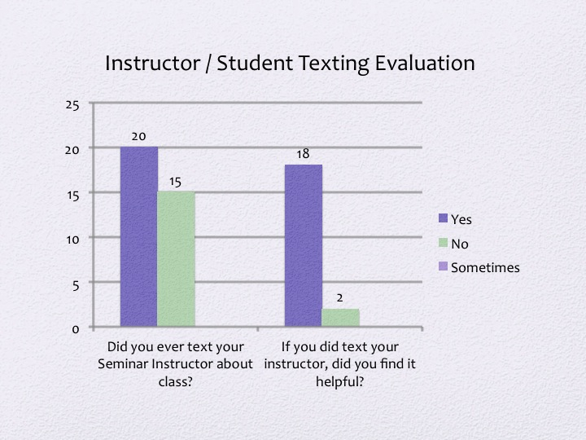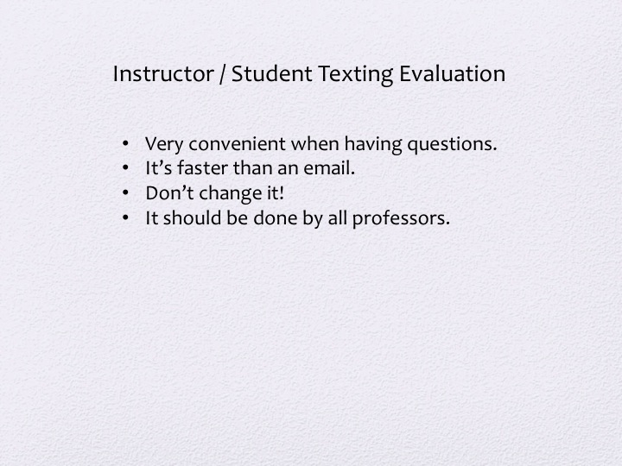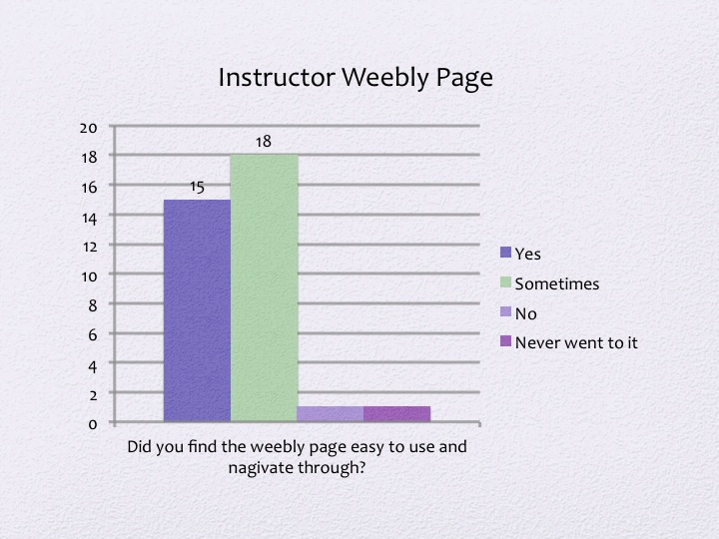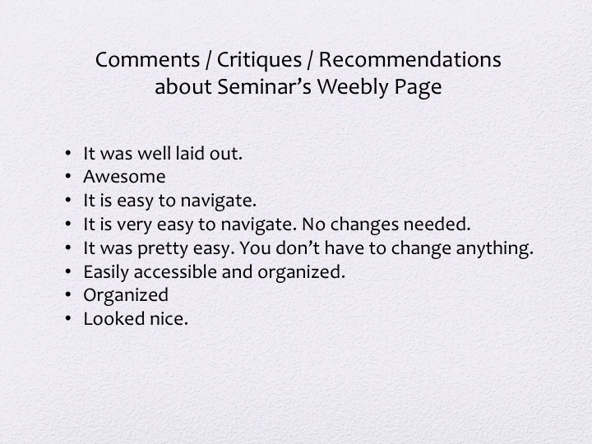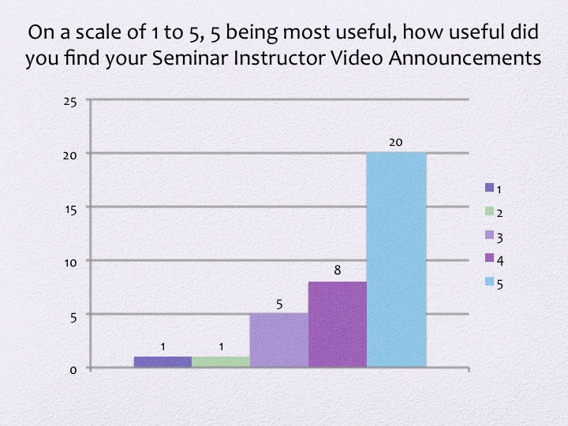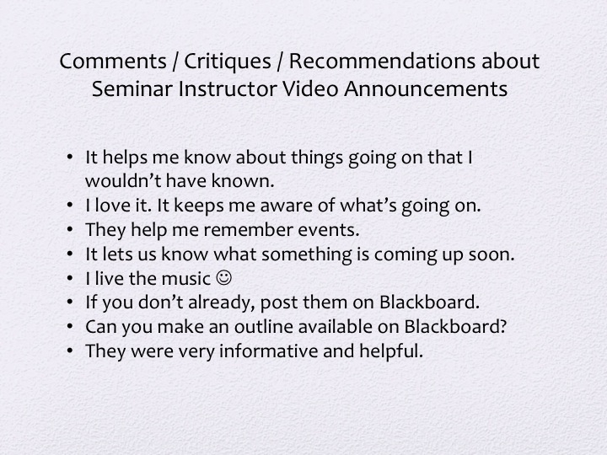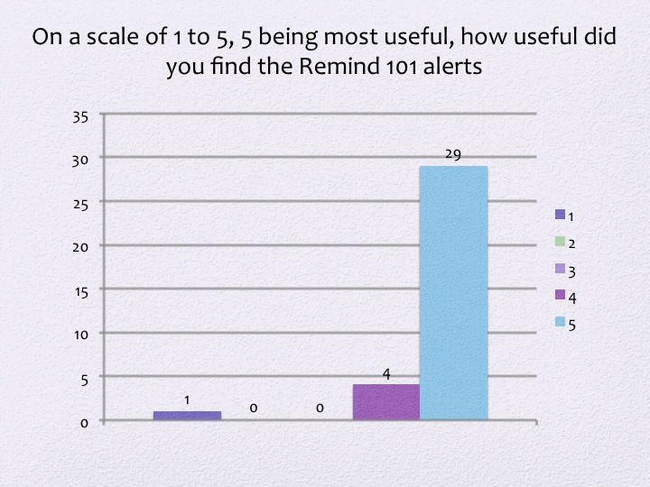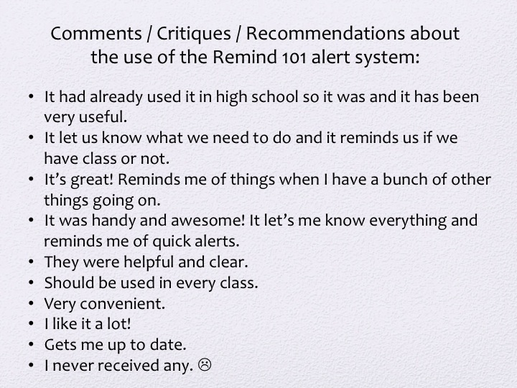
References

Carraway, C., & Burris, S. (2013). Teaching Digital Natives: Is There An App For That? The
Agricultural Education Magazine, 85(6).

Hoder, R. (2014, June 19). Why Parents Shouldn't Fear Teacher-Student Texting. Retrieved
December 14, 2014, from http://time.com/2896901/teacher-student-texting/

Jannene, J. (2014, March 11). The Power to Teach. Retrieved December 14, 2014, from
http://www.thepowertoteach.com/remind101-a-safe-way-to-keep-in-contact-with-students-and-parents-via-text/

Rhode, J. (2012, February 9). Text Messaging with Students While Maintaining Privacy. Retrieved December 14, 2014, from http://facdevblog.niu.edu/textmessaging

