Retention Help: Utilizing Islander Success Advocates in Learning Communities

Specific Context

Student Learning Outcomes:
After completing a semester with an Islander Success Advocate in the First-Year Seminar classroom, students will be able to –

- Identify the campus resources and what they are there for;
- Feel more comfortable using those resources when needed;
- Feel more comfortable to ask questions in the classroom and to interact with their peers;
- Identify issues that they may be having and know where to go to receive guidance.

Islander Success Advocates

The Islander Success Advocates (ISA) are academically successful upper-division and graduate students who are trained to provide academic assistance to all first-year students. All of them have their own experiences and personalities to bring to the job in order to better assist a large variety of students.

ISA focuses on connecting with incoming first-year students by addressing both the academic and social needs of each student. Islander Success Advocates aim to help all first-year students to make a smooth transition to ensure academic success.

Advocates can help an Instructor with:
- Peer Editing Class Assignments
  - Advocates can give comments on assignment such as questions that students may have or concerns. This way the instructor could be prepared on how to address them in class.

- Assist with Ice Breakers
  - Students may be unwilling to participate in the beginning of the semester. Advocates can energize the class and encourage students to enjoy the activities. They also have ideas and resources for coming up with more Ice Breaker ideas.

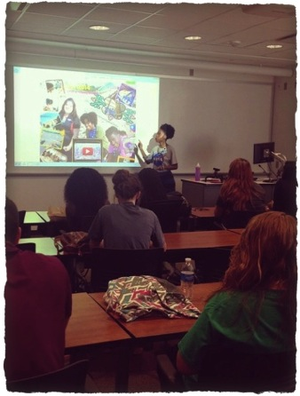
- Assist with Student Conferences
  - If allowed to sit in, Advocates can be of help during student conferences. They can assist with encouraging students to ask questions and to be fully prepared for the conference. Advocates can also help in answering questions or concerns that students may have about school or about the assignment.

- Elaborate on Importance of Coursework
  - Students are constantly asking or wondering why they have to do certain activities or learn certain subjects/skills. Advocates can help by discussing how those skills can help them in future courses and/or careers.

- Help with Class Participation
  - When an instructor asks the class a question, students can be shy and remain quiet. Advocates can participate by asking questions that students may have, in order to get them feeling comfortable to ask.
  - During in-class activities, particularly with group work, students can get easily distracted. Advocates can help by walking around the classroom and keeping the students focused on the task.

Assessment Tools

Student Learning Outcomes | Assessment Activity | Inclusion of ISA
Identifying Campus Resources | Pre/Post Survey on how well students are able to identify campus resources and what they are used for. | Throughout the semester, presentations will be given on the resources and encouragement given to use them.
 | Campus Resource Scavenger Hunt | CASA will be part of the hunt and the advocate can show students how to find the resources.
CASA / WC / SI Slips | Students can bring these slips in for bonus points on class activities or to replace missing work for partial credit. | Advocates will be there in class to help students with questions they have and encourage them to visit their office or those other campus facilities.
Registration Worksheet | Requires students to visit with an advisor or advocate (preferably) to get their schedule made and requires a signature from who they say. | ISA would be strongly recommended to visit and they would give a presentation on how they are able to help with registration.
Professor / ISA Interview | Students would be required to interview one of their instructors in their learning community along with an advocate. Afterwards, they would write a reflection on their experiences. | The advocate would be able to show the student around CASA, show them the process of being able to see an advocate, along with further explaining how they can help students.
Reflections / Final Portfolio | Students will be given the opportunity to reflect on any issues/concerns that they may be having. Can reflect on what new skills they have gained and experiences they have had on campus. | Would be an opportunity to see if any of the advocates are mentioned. It is also a chance for them to assist the students to see all they have accomplished in the semester.

Student Survey Results on Islander Success Advocates

An anonymous survey was given to the Dyad J and Dyad L Seminar students in sections 434, 432, 433, 490 and 491. The survey was a CASA developed survey given to the student in Spring 2015. Each of the sections had an Islander Success Advocate assigned to their classroom. The following are the results of the survey given.

What help did the students receive from their Islander Success Advocate?

- Holds
- Registration
- Questions about class
- Declaring / Changing majors
- Study tips
- Time management

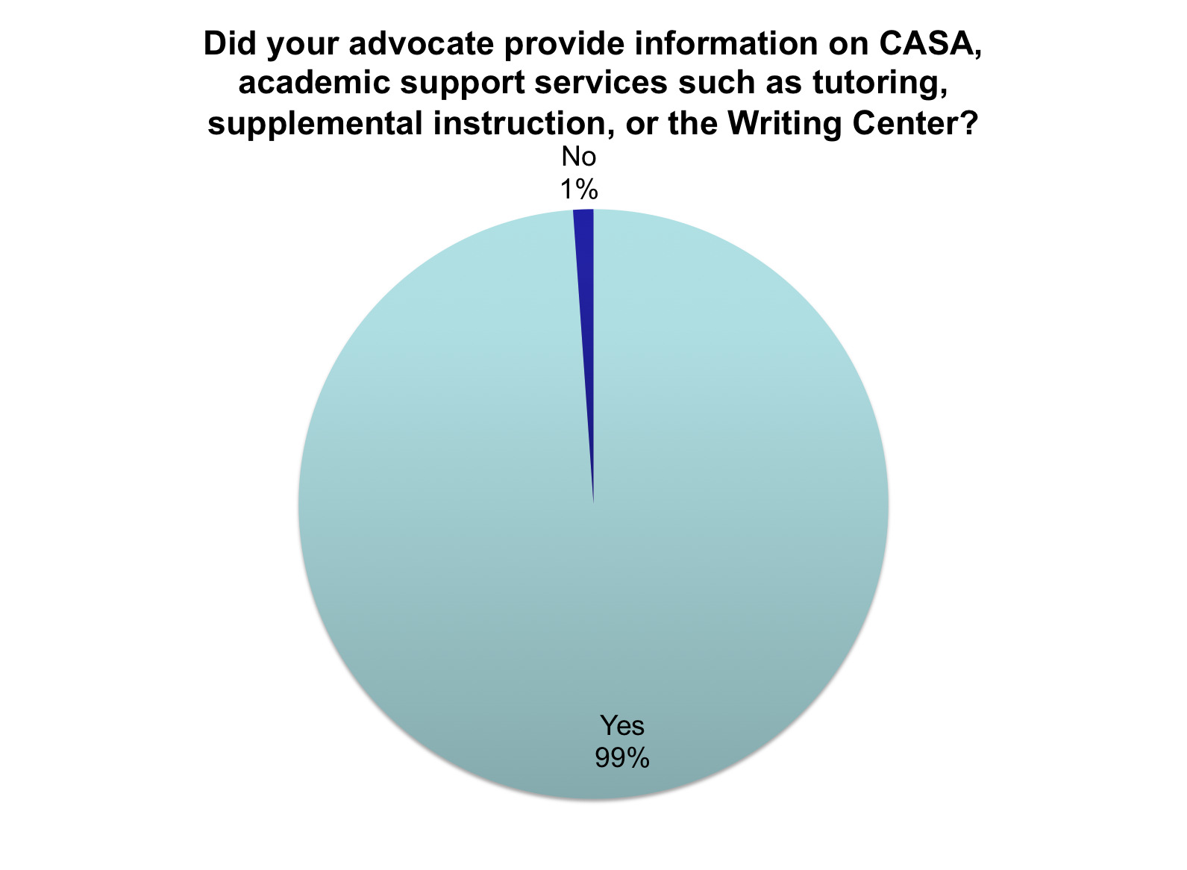

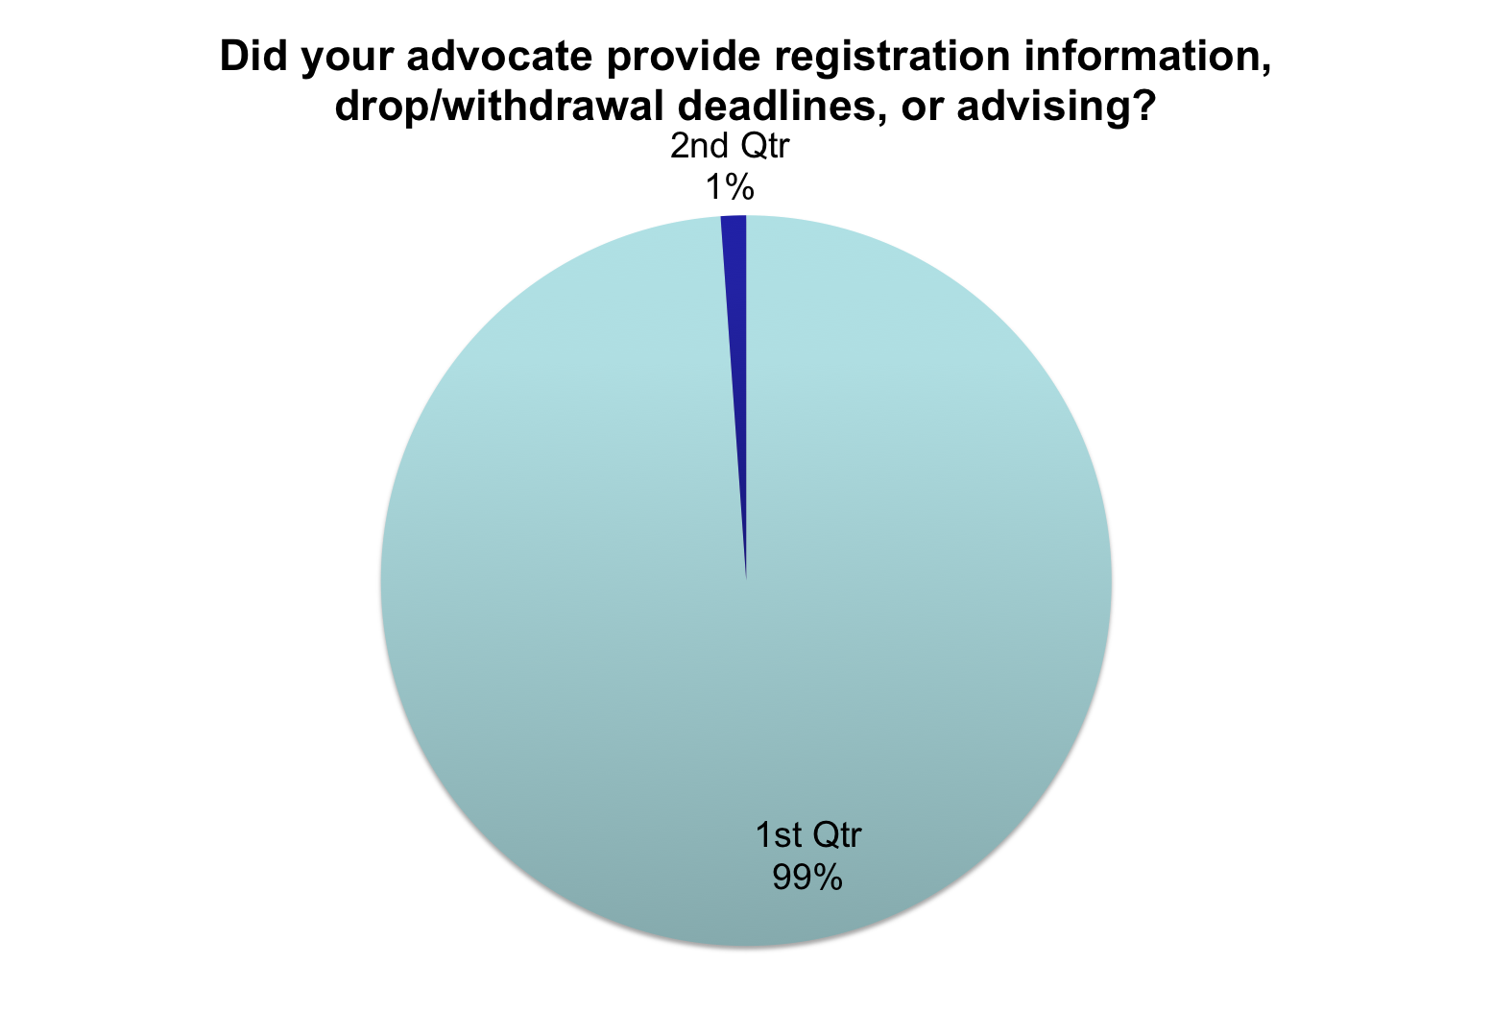
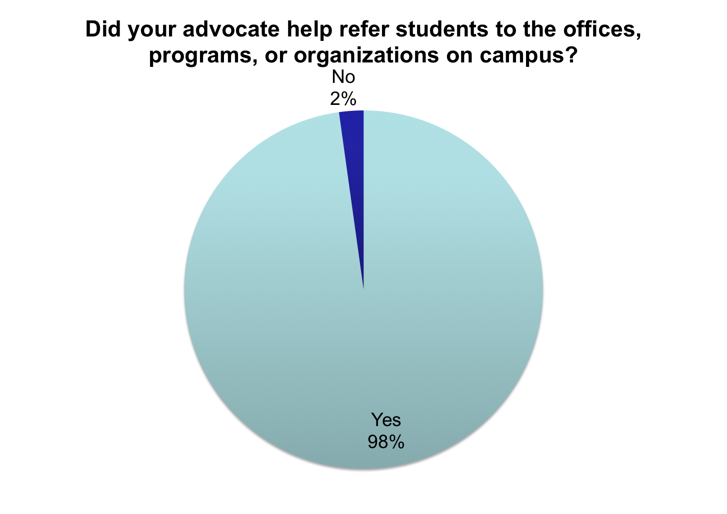

Student Comments

AVID helped me get to college more than any of my other classes and actually helped me get to the school I wanted. My mentor was a blessing to me for aiding me in achieving one of my biggest accomplishments.

~Kimberly H.

AVID has really helped me decide on what classes to take, and the workers are very friendly and helpful. I would highly recommend any new coming freshman to the university to make an effort to meet with their AVID Mentors for any concerns they may have.

~Nicole H.

Having an AVID mentor I feel benefits students because you not only have the professor to help you but also someone who is a actual student and knows what you are going through now to help answer questions in anything you need help in. From financial aid to calculating your GPA AVID mentors seem to have a student understanding and know where you should go if they can’t help. But overall having AVID mentors does nothing but benefit the learning community that the University is trying to provide.

~Sarybeth W.

In my freshman year, I don’t know what I would do without them. AVID Mentors clarified what instructors said, explained assignments, helped me with my emotional needs, and gave me advice that I greatly appreciated.”

~Anthony V.

For the full survey results, please visit:
- http://www.surveymonkey.com/results/SM-JRMMCG79
- http://www.surveymonkey.com/results/SM-BMFZ2G79

Utilizing Islander Success Advocates Effectively

Communication is key:

- Communicate with the advocates on how they can help you in the classroom.

- Keep the advocates up-to-date on what is going on with the class that week and even the following week.

- Make it clear, to the advocates, what classroom behavior you would like them to model for the students.

- It is also beneficial to include them on any class listserves or learning community listserves. That way, the advocates can be up-to-date on what the students are being aware of and what to expect in class that day.

Acknowledgements

Special thanks to Mr. Hector Duarte, Ms. Sabrina Simpson, Ms. Elizabeth Bradshaw, Ms. Regina Edwards and all of the advocates who have been an amazing help to me and my seminar students.

Contact Information

Ms. Jennifer Lauren Simpson, M.P.A.
jennifer.simpson@tamucc.edu
Faculty Center Room 119
simpsonjl.weebly.com
361-739-3836

