Student Administered Polls: Building a Personal Connection to Learning
Jennifer Lauren Simpson, MPA
Texas A&M University – Corpus Christi
jennifer.simpson@tamucc.edu

Goals

Many classes have a research paper as part of their curriculum for students to complete as the major project for the semester. I have added the component of conducting a poll to the research paper.
In my Political Science Seminar class, polling helps students to better understand the public’s opinion on their political research topics. It also helps them see how different groups of people think.
Learning Goals:
- Understand real-world observations and the data it produces.
- Time-Management
- Excel / Numbers Program
- Data Analysis
- Creating un-biased research questions based off of research conducted.
- Communication Skills
Polls are something they read about in their textbook and research. This gives them the opportunity to conduct one of their own.

Polling Assignment Lesson Plan

Day 1: Introduce assignment; discuss the dos and don’ts; place students in a group of 3-4 to pick a poll topic. Homework is to bring back their polling questions.
Day 2: Finalize polling questions and conduct their poll (preferably online).
Day 3: Bring back poll results and work on creating data tables.
Day 4: Polling Presentations

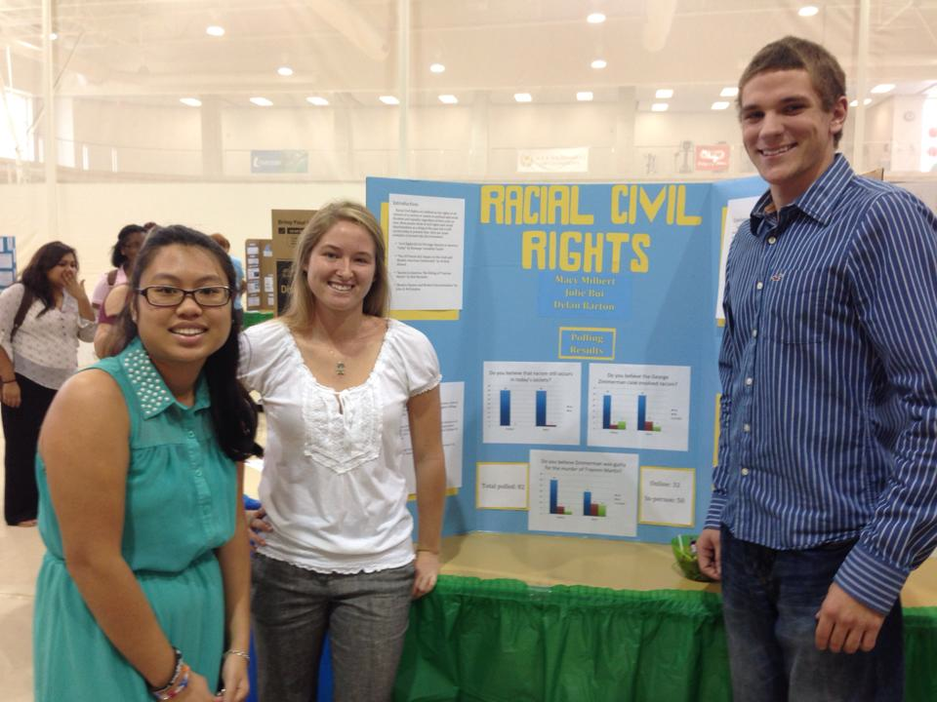

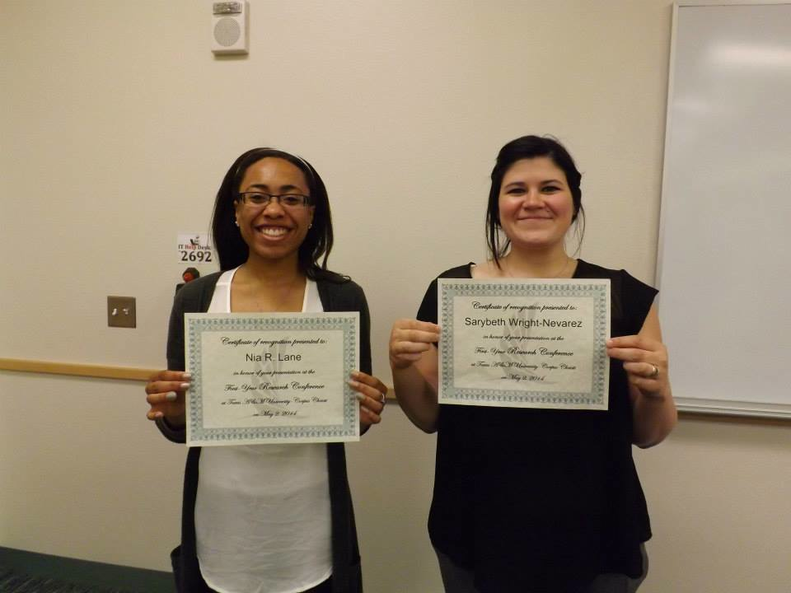
Assignment Requirements

- Construct 3-5 polling questions, plus demographic question(s)
- Plan for a poll sample
- Collect all responses and review the results. Minimum of 30 responses.
- Prepare data tables of the results to be incorporated within their paper and poster presentations.

Grade based on the following:
- Poll structure
- Poll questionnaire
- Data table presentation

Student Work Examples

First Year Symposium
- Each first-year student participates in FYS in the Fall Semester. It is their chance to visually present their research paper as a poster board presentation.

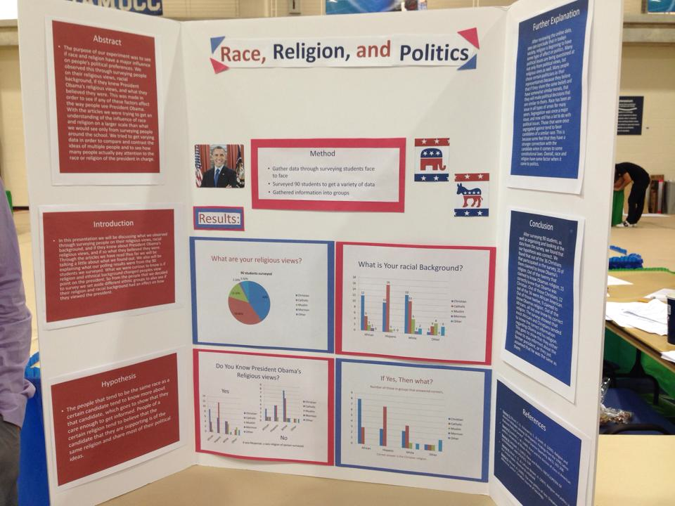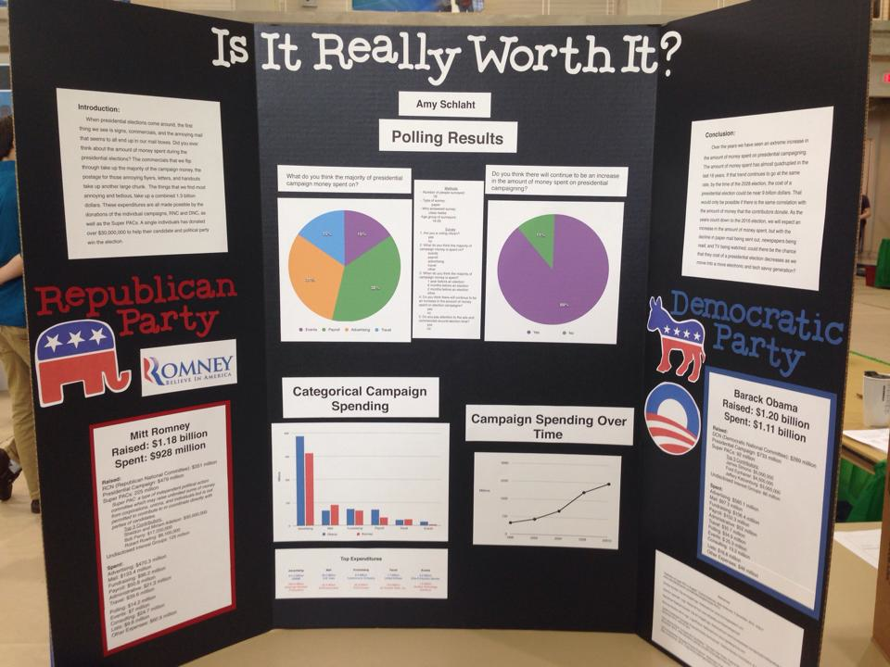

First Year Research Conference
- Each first-year students has the opportunity to apply to present at the FYRC in the Spring Semester. Students must demonstrate proper research, use of reliable sources, and professional writing skills. Presentations are in a multimodal format.

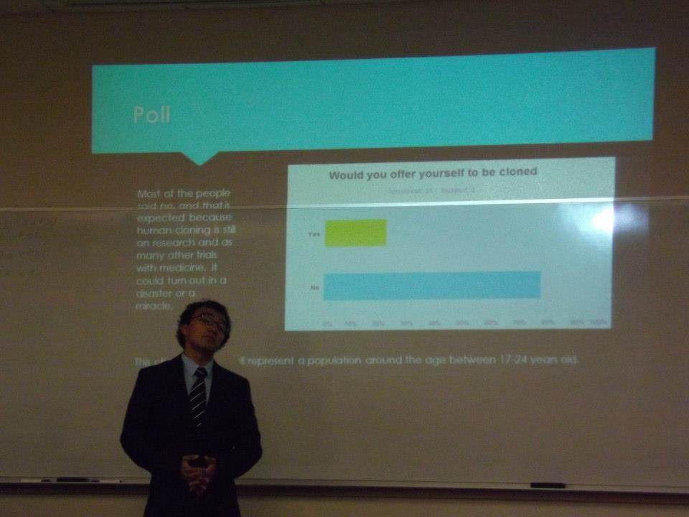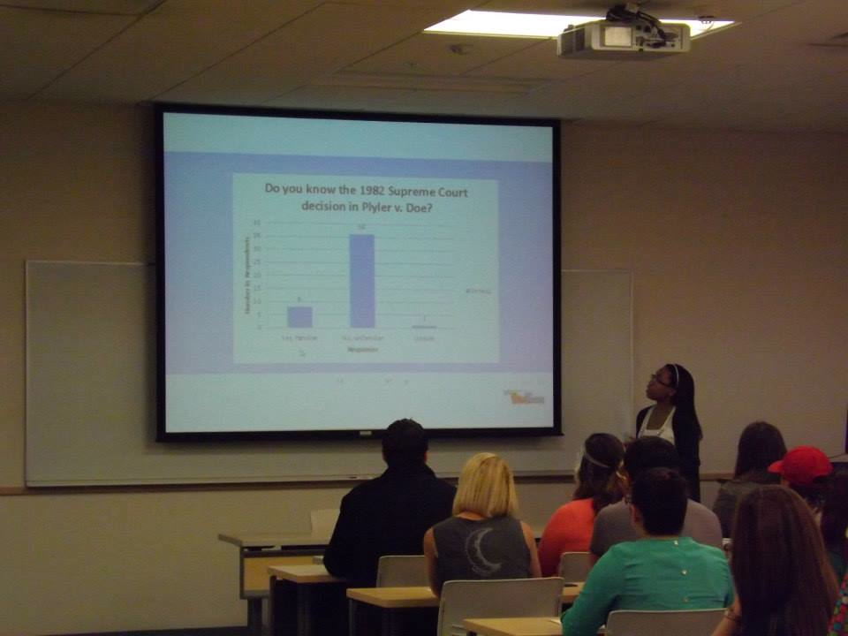

Free Polling Websites

- Poll Everywhere: www.polleverywhere.com
- Survey Monkey: www.surveymonkey.com
- Google Forms: www.google.com/forms/about/
- Easy Poll: www.easypoll.net
- Poll Maker: www.poll-maker.com
Polling Introduction Lesson Plan

https://studentwiki.tamucc.edu/wiki/JenniferSimpson/Polling

Polling Assignment Sheet

https://studentwiki.tamucc.edu/wiki/JenniferSimpson/PollingAssignment

Polling Assignment Grading Rubric

https://studentwiki.tamucc.edu/wiki/JenniferSimpson/PollingRubric

References

Chabot, Philippe. “Using Online Polls to Trigger Students’ Interest!” Web log post. My Professional Blog as an English Teacher. WordPress, 24 Apr. 2013. Web. 21 Apr. 2014

How to Conduct A Poll: Teacher’s Guide.N.p.: Pearson Education, 2012. Print.

Kelley, K., Clark, B., Brown, V., & Sitzia, J. (2003). Good practice in the conduct and reporting of survey research. International Journal for Quality in Health Care, 15(3), 261-266. Retrieved December 2, 2014, from http://intqhc.oxfordjournals.org/content/intqhc/15/3/261.full.pdf

Orlando, John. “Using Polling and Smartphones to Keep Students Engaged.” Faculty Focus. N.p., 4 Oct. 2010. Web. 21 July 2014.

